YOUR PERSONAL FINANCIAL ORGANIZER

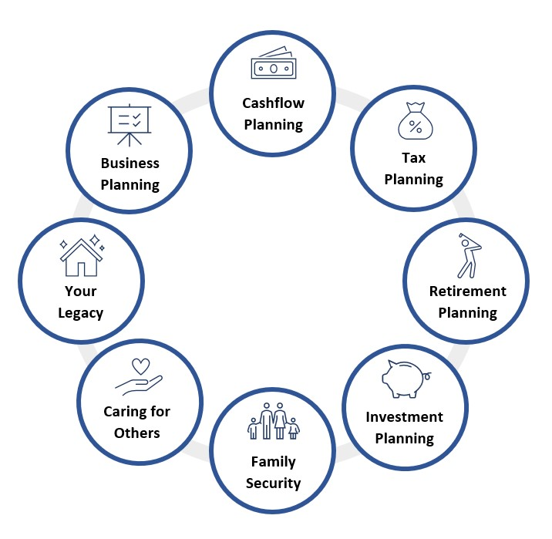
Helping You Manage Your Critical Financial Events
Client Name
Date

The PFO is the foundation of our wealth management process.
Your Personal Financial Organizer (PFO) is an important written document that clearly defines your financial goals and objectives over a relevant, explicitly stated time horizon. As your financial advisor, creating and maintaining this document is one of my key responsibilities.

It establishes a long-term plan to guide your financial decisions.
The PFO helps to balance your goals and objectives with other essentials. It addresses concerns including: your safety net, debt management, tax planning, educational planning, retirement planning, estate planning, and investment strategy. The PFO is designed to encompass every aspect of the personal wealth management process – it helps you plan and prepare for critical financial events.
The PFO creates a path to achieving your financial and lifestyle goals.
By using a well-constructed PFO, you will follow a carefully considered and disciplined approach to wealth management. Many people - and their financial advisors - are tempted to make ad hoc decisions about their financial situation - decisions that are often based on panic or overconfidence. The PFO will make sure that you consider the long-term and evolutionary nature of the wealth management process. It will clearly and concisely identify the constraints and opportunities of your current financial situation, while also focusing on your goals and objectives. The Result: Your financial plan will attend to your short-term needs without losing sight of your long-term goals.

Using the PFO, we can work together to establish guidelines that we both feel appropriate to your situation, given the strategies available and the realities of the marketplace.
It’s a Collaborative Effort – Our Partnership

You are responsible for participating in the successful implementation of your PFO. I will, however, guide you through this process. Once you have established your priorities and disclosed all related information, I will provide you with advice and solutions to help you achieve them. We will, of course, regularly reevaluate and update the PFO. This plan evolves in response to personal and family changes, and the PFO must adapt to these changes.

In addition, the PFO will coordinate the efforts of other professionals (accountants, lawyers, etc.) that we choose to consult as part of the wealth management process.
A professionally prepared PFO will track your progress and it will provide continuity from one year to the next. The PFO will also help to prevent misunderstandings, because it clearly explains the nature of our relationship and the strategies we have agreed to implement.

What’s Important to You?

Long-term Goals (10 years and longer)
Goal:
Strategy:
Goal:
Strategy:
Goal:
Strategy:
Medium-term Goals (5 to 10 years)

Goal:
Strategy:
Goal:
Strategy:
Goal:
Strategy:
Short-term Goals (1 to 5 years)

Goal:
Strategy:
Goal:
Strategy:
Goal:
Strategy:
Immediate Goals (Less than 1 year)

Goal:
Strategy:

Who’s Important to You?

Strategy:

Parents
Children
Grandchildren & Great Grandchildren
Other Important People
Siblings
Important Organizations & Causes

Your Wealth Management Team

Professional | Contact Information
Financial Advisor | Name:  Phone:  Email:
Accountant/CPA | Name:  Phone:  Email:
Lawyer/Attorney | Name:  Phone:  Email:
Insurance Agent | Name:  Phone:  Email:
Personal Banking Advisor | Name:  Phone:  Email:
Commercial Banking Advisor | Name:  Phone:  Email:
Mortgage & Lending | Name:  Phone:  Email:
Other | Name:  Phone:  Email:
Other | Name:  Phone:  Email:

Your Wealth Management Checklist

Comprehensive Wealth Management: | Areas Important to You
1 Cash Flow Planning

2 Tax Planning

3 Retirement Planning

4 Investment Strategy

5 Family Security
6 Caring for Others

7 Your Legacy

8 Business Planning & Succession

9 Special Situations

Your Cash Flow Planning

Net Worth Statement
Strategy:
Date Last Reviewed:
Next Action:
Cashflow Analysis
Strategy:
Date Last Reviewed:
Next Action:
Emergency Funds
Strategy:
Date Last Reviewed:
Next Action:
Mortgage Considerations
Strategy:
Date Last Reviewed:
Next Action:
Debt Analysis
Strategy:
Date Last Reviewed:
Next Action:
Other Cashflow Strategies
Strategy:
Date Last Reviewed:
Next Action:

Your Tax Planning

Income Splitting
Strategy:
Date Last Reviewed:
Next Action:
Interest Income
Strategy:
Date Last Reviewed:
Next Action:
Dividend Income
Strategy:
Date Last Reviewed:
Next Action:
Capital Gains
Strategy:
Date Last Reviewed:
Next Action:
Other Tax Planning Strategies
Strategy:
Date Last Reviewed:
Next Action:

Your Retirement Planning

How Much Is Enough?
Strategy:
Date Last Reviewed:
Next Action:
RRSPs
Strategy:
Date Last Reviewed:
Next Action:
TFSAs
Strategy:
Date Last Reviewed:
Next Action:
Annuities
Strategy:
Date Last Reviewed:
Next Action:
Employment Pensions
Strategy:
Date Last Reviewed:
Next Action:
CPP & OAS Pensions
Strategy:
Date Last Reviewed:
Next Action:
Other Retirement Strategies
Strategy:
Date Last Reviewed:
Next Action:

Your Investment Strategies

Determining Your Risk Tolerance
Strategy:
Date Last Reviewed:
Next Action:
Investment Policy Statement
Strategy:
Date Last Reviewed:
Next Action:
Asset Allocation & Rebalancing
Strategy:
Date Last Reviewed:
Next Action:
Investment Structure & Ongoing Management
Strategy:
Date Last Reviewed:
Next Action:
Other Investment Strategies
Strategy:
Date Last Reviewed:
Next Action:

Your Family Security

Home & Property Insurance
Strategy:
Date Last Reviewed:
Next Action:
Life Insurance
Strategy:
Date Last Reviewed:
Next Action:
Disability Insurance
Strategy:
Date Last Reviewed:
Next Action:
Critical Illness Insurance
Strategy:
Date Last Reviewed:
Next Action:
Asset Protection and Creditor Proofing
Strategy:
Date Last Reviewed:
Next Action:
Other Family Security Strategies
Strategy:
Date Last Reviewed:
Next Action:

Caring for Others

Registered Education Savings Plans (RESPs)
Strategy:
Date Last Reviewed:
Next Action:
Income Splitting with Your Children
Strategy:
Date Last Reviewed:
Next Action:
Caring for Children with Special Needs (RDSPs)
Strategy:
Date Last Reviewed:
Next Action:
Caring for Children with Special Needs (Trusts)
Strategy:
Date Last Reviewed:
Next Action:
Caring for Elderly Parents
Strategy:
Date Last Reviewed:
Next Action:
Other Care Planning Strategies
Strategy:
Date Last Reviewed:
Next Action:

Your Legacy

Will
Strategy:
Date Last Reviewed:
Next Action:
Living Will
Strategy:
Date Last Reviewed:
Next Action:
Power of Attorney
Strategy:
Date Last Reviewed:
Next Action:
Executor Appointed
Strategy:
Date Last Reviewed:
Next Action:
Principal Residence
Strategy:
Date Last Reviewed:
Next Action:
Additional Properties
Strategy:
Date Last Reviewed:
Next Action:
Trusts
Strategy:
Date Last Reviewed:
Next Action:

Inheritances
Strategy:
Date Last Reviewed:
Next Action:
Probate Strategies
Strategy:
Date Last Reviewed:
Next Action:
RRSP and RRIF Taxation Strategies
Strategy:
Date Last Reviewed:
Next Action:
Income Splitting with Your Estate
Strategy:
Date Last Reviewed:
Next Action:
Long-Term Care
Strategy:
Date Last Reviewed:
Next Action:
Charitable Donations
Strategy:
Date Last Reviewed:
Next Action:
Other Estate Planning Strategies
Strategy:
Date Last Reviewed:
Next Action:

Business Planning & Succession

Small Business Capital Gains Exemption
Strategy:
Date Last Reviewed:
Next Action:
Stock Options
Strategy:
Date Last Reviewed:
Next Action:
Buy-Sell Agreements
Strategy:
Date Last Reviewed:
Next Action:
Commercial Insurance
Strategy:
Date Last Reviewed:
Next Action:
Key Man & Other Specialty Insurance
Strategy:
Date Last Reviewed:
Next Action:
Other Business Planning Strategies
Strategy:
Date Last Reviewed:
Next Action:

