Kit – Handwritten Card for Existing Clients
Step 3

This stunning greeting card is to be handwritten and attached to your Introduction Kit.

To simplify things, we recommend you use the same card you send with the Introduction Kit for Prospective New Clients. You can earmark a specific card image as “Accompanies Introduction Kit”.

Dear Existing Client,

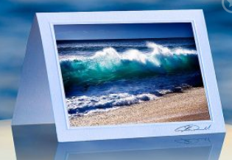
I hope all is well and look forward to catching up with you soon.

Here is the Introduction Kit we mentioned. We send this out now before we meet with a prospective client for the first time as part of our process.

See you soon,

Advisor's Signature

